The Uncommon Garden Gala
May 3, 2014

Uncommon Sponsorship Opportunities
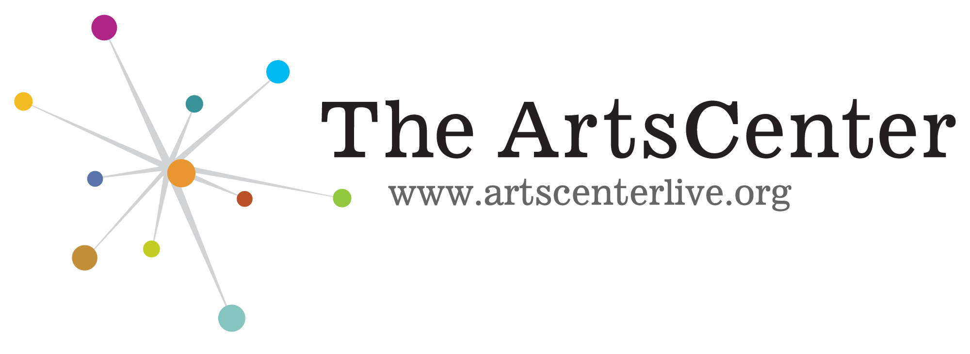 300-G East Main St., Carrboro, NC 27510
Call Julie: 919-929-2787 x 213 for more info
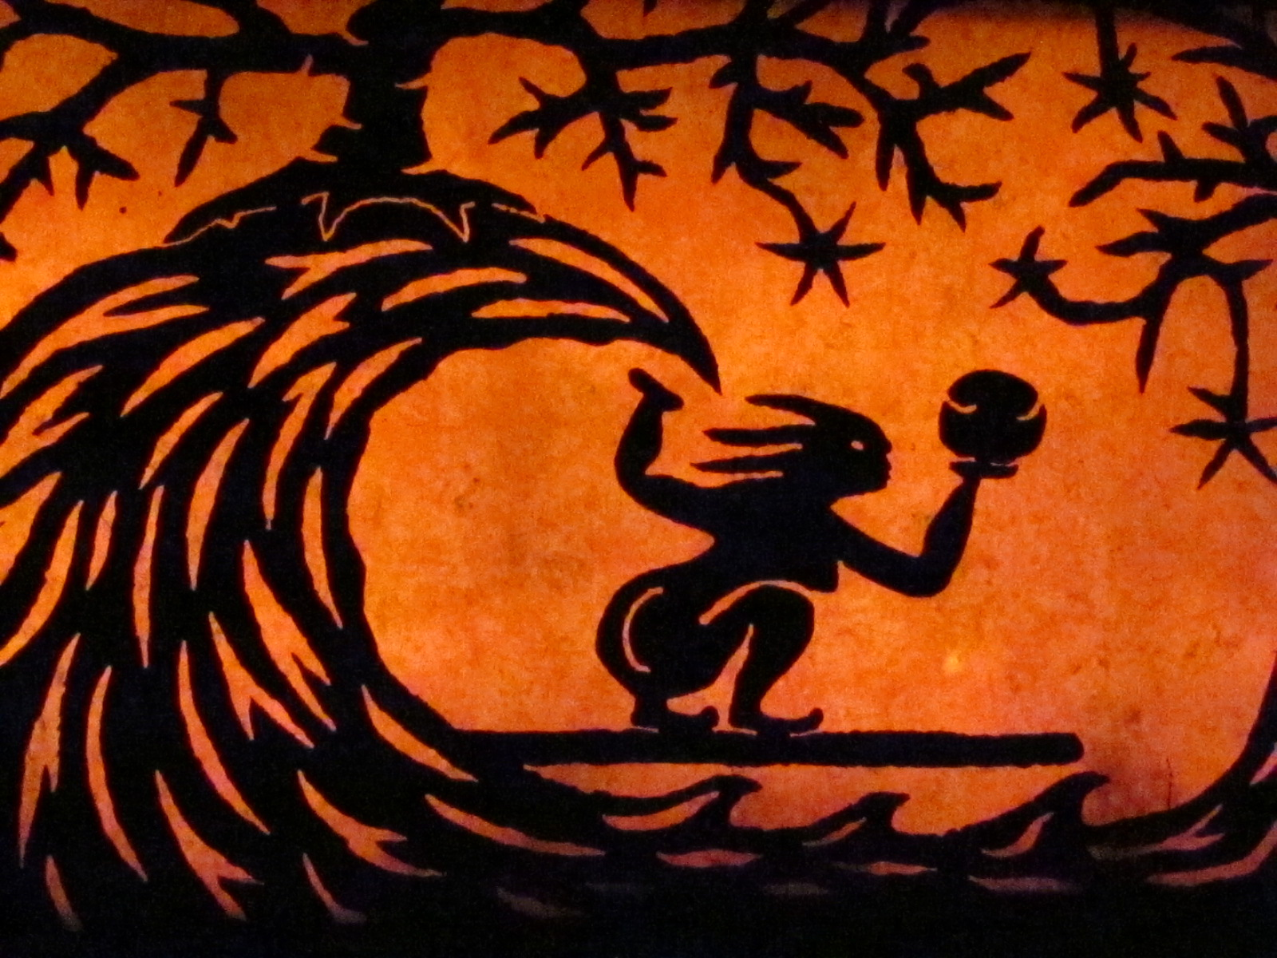

DRAGON LEVEL- Title Sponsor $7500. Only one available. Includes naming rights, 12 tickets, recognition in advertising and promotion, display ad on ArtsCenter website for one year, signage on site, ad in program, and recognition in announcements. Lucille is one the garden’s mythical dragon with horseshoe crab whiskers, quartz fangs and laser eyes. Intricate construction with small stones creates her scales. See Map area 9.

TEMPLE CAVE & COURTYARD LEVEL- Presenting Sponsor $3500. Only one available. Includes “presented by” recognition, 6 tickets, recognition in advertising and promotion, display ad on ArtsCenter website for six months, signage on site, ad in program, and recognition in announcements. This cave has a cantilevered overhang/waterfall overlooking the Mountain Pool. See Map area 15/16.

AMPHITHEATER LEVEL- Major sponsor $2500. Only four available. Includes 6 tickets, recognition in advertising and promotion, display ad on ArtsCenter website for 3 months, signage at amphitheater, and recognition in program and announcements. See Map area 17.
MTN POOL & GAZEBO LEVEL- Supporting Sponsor $1500. Only six available. Includes 4 tickets, recognition in advertising and promotion, display ad on ArtsCenter website for 1 month, signage at Gazebo, and recognition in program and announcements. Two tall boulders spring from the center and together gently suspend a glass, as the artist’s tribute to the twin towers of 9/11. See Map area 14.

SUN PATIO LEVEL- Supporting Sponsor $1000. Only ten available. Includes 6 tickets plus an extra drink ticket for each, recognition in advertising and promotion, listing on UGT website, signage at Sun Patio, and recognition in program and announcements. Authentically and proportional Japanese Torii Gates made with rustic cedar logs create the swing framework. See Map area 5.

Other levels

- $750 ZEN FOUNTAIN & BUDDA BENCHES LEVEL- Includes 5 tickets plus an extra drink ticket for each, recognition in the program, on a sign at Zen Fountain, and in the announcements. See Map area 2.
- $500 WAVE ROOM & PORTAL BETWEEN WORLDS LEVEL- Includes 3 tickets plus recognition in the program, on a sign at Wave Room, and in the announcements. See Map area 4.
- $350 HORSESHOE FALLS & GAME TABLE LEVEL- Includes 2 tickets plus recognition in the program, on a sign at Horseshoe Falls, and in the announcements. See Map area 7.
- $250 TORI GATE HILL LEVEL—Includes 1 ticket plus recognition in the program, on a sign at Tori Gate Hill, and in the announcements. See Map area 8.
- $150 SNAKE BRIDGE LEVEL- Includes recognition in the program, on a sign at Snake Bridge, and in the announcements. See Map area 10.

